Gambling Harm Awareness Week 2025

Industry Supporter Toolkit
Contents
Introduction 2
What is Gambling Harm Awareness Week? 2
Why is it important for industry to participate? 2
Campaign concept and messaging 2
Key messages 3
Quick facts about gambling harm in Victoria 3
Quick guide: How to support Gambling Harm Awareness Week 4
Resources for Gambling Harm Awareness Week 2025 5
Posters 5
Digital assets 6
Social media 6
Tips for engaging the media 7
Engaging local media 7
Key contacts at the VGCCC 8

Introduction
This industry supporter toolkit contains all you need to know about how to support Gambling Harm Awareness Week (GHAW) 2025. It is designed for gambling providers who would like to support the week and promote the campaign in venues and to their networks.
The toolkit outlines a range of promotional materials that include digital assets, posters and other resources to promote the Gambling Harm Awareness Week to your patrons.

What is Gambling Harm Awareness Week?
Gambling Harm Awareness Week will run from 27 October to 2 November 2025. This annual event raises awareness of gambling harm in the Victorian community and encourage discussion about how gambling affects individuals, families, and the community.

Why is it important for industry to participate?
Gambling products can make it easy to get caught up in the moment. Their immersive nature can make it hard for people to keep track of how long they have been playing and how much they are spending.
Gambling venues and their staff have an important role to perform in actively monitoring the welfare of their patrons, discouraging intensive and prolonged gaming machine play and intervening when a player is displaying behaviour consistent with gambling harm. The effects of gambling harm are wide ranging and extend beyond the financial to include:
- self-esteem
- relationships
- physical and mental health
- work performance
social life.

Campaign concept and messaging
The campaign theme for industry aligns with VGCCC’s regulatory stance. It highlights the industry's role in harm reduction and provides venue staff with a clear, actionable message to encourage gambling staff to monitor the welfare of their customers and provide support when they’re displaying behaviours consistent with gambling harm.

If the customer is emotional or showing signs of gambling harm, staff can find initiating a conversation difficult. The campaign provides links to material developed by the Department of Health on how best to start a conversation with customers showing signs of gambling harm to provide support and encourage a break from play.

Key messages
Make the call.
Encourage a break from play.

- Empower gambling venue staff to monitor the welfare of their customers.
- Provide staff with the tools to support customers when they’re displaying behaviours consistent with gambling harm.

Quick facts about gambling harm in Victoria
- Approximately 440,000 Victorians are either at risk of, or already experiencing gambling harm.
- Those most likely to experience gambling harm are people who gamble on casino table games (36%), followed by sports (35%), bingo (32%) and poker machines (29%).
(Source: Victorian population gambling and health study 2023)

- Common signs of gambling harm include:
  - stress
  - irritability
  - difficulty sleeping or concentrating
  - drinking or smoking more than usual
  - not spending as much time with family or friends
  - frequently borrowing money
  - intermittent periods of having lots of cash and no cash.

- Many people experience negative effects from gambling, like stress, regret and guilt, no matter how much or how often they gamble. These effects can start off small and build up, causing stress in their lives.

Quick guide: How to support Gambling Harm Awareness Week

You can support the week by sharing campaign assets with your networks and placement of patron materials in gaming areas, and displaying campaign posters directed at your staff in dedicated staff spaces. By participating in the campaign, together we can help build awareness of gambling harm and work towards reducing its impact upon the Victorian community. Find the full list of resources and more on the VGCCC website.
Display Make the Call poster in your in staff only spaces.
Display a Gambling Harm Awareness Week poster in your in venue.

Add a Gambling Harm Awareness Week email signature, teams meeting background, display banner on your website or social media asset in your feed.

Follow, share, and comment on Gambling Harm Awareness Week social media using the hashtags #GamblingHarmAwarenessWeek2025

Resources for Gambling Harm Awareness Week 2025
Explore the range of downloadable resources and make a plan to promote, share, and display them in the lead up to, and during, Gambling Harm Awareness Week.

Posters
Display posters in your venue to get people thinking and talking about gambling harm.
Preview | Poster title | Description
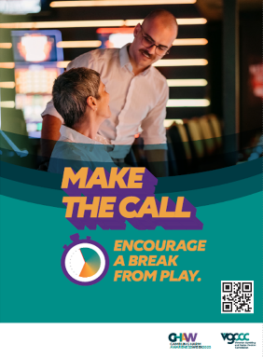  Make the Call | A3 poster | A3 portrait poster that encourages venue staff to monitor the welfare of their customers and provide staff with the tools to help provide support when customers are displaying behaviours consistent with gambling harm.  Display this poster in venue staff spaces only – available from 13 October
GHAW branded 4 protective behaviours poster  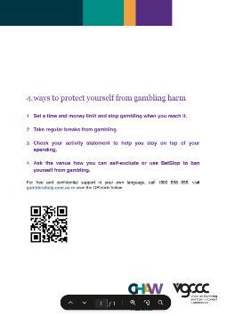 | A4 poster  A3 poster | A3 and A4 portrait posters explain how people can protect themselves from gambling harm with link to Gambler’s Help.  Display this poster in venue gambling areas.
GHAW branded 4 protective behaviours CALD poster  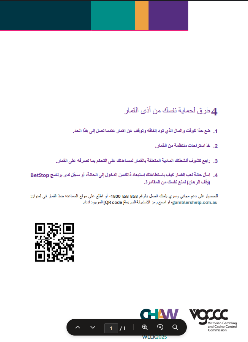 | A4 poster  A3 poster | A3 and A4 CALD portrait posters explain how people can protect themselves from gambling harm with link to Gambler’s Help  Display this poster in venue gambling areas.

Digital assets
This is a great way to promote the week to internal and external contacts. There are a range of assets for you to use.
Assets for download include:
- GHAW logo
- Email signature and header
- GHAW branded static digital banners
- GHAW branded e-newsletter template
- GHAW branded social media tiles
- GHAW campaign social media tiles
- GHAW branded Microsoft Teams background
- GHAW branded A4 flyer header

Social media
GHAW branded and campaign social media assets will help you promote Gambling Harm Awareness Week on your Facebook, Instagram, and LinkedIn pages. To assist with the promotion see suggested social media post content:
Post topic | Copy | Asset
Supporting GHAW 2025  (pre-week)  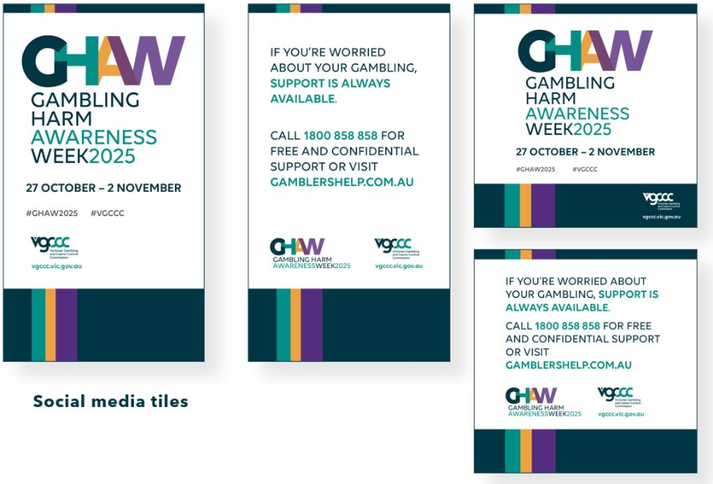 | We’re proud to support Gambling Harm Awareness Week and help reduce the risk of gambling harm.  Mark your calendar for 27 October – 2 November to raise awareness and reduce the risk of gambling harm.  Find out more: Gambling Harm Awareness Week | Victorian Gambling and Casino Control Commission  #GamblingHarmAwarenessWeek2025 | Image: Gambling Harm Awareness Week tile  - 4x5 for feed  - 9x16 for Instagram/Facebook story
How to get support | If you’re worried about your gambling, support is always available.  Call 1800 858 858 for free and confidential support or visit gamblershelp.com.au.  #GamblingHarmAwarenessWeek2025 | Image: Support is always available  - 4x5 for feed  - 9x16 for story

Social media tips
Social media is a great way to promote your participation and support of Gambling Harm Awareness Week.
Best times to post include:
- Before the week to let your followers know GHAW is coming up.
- Publish your posts during key social viewing times (commute times, lunch and after dinner)
Where possible, link back to the Gambling Harm Awareness Week campaign page on the VGCCC website so people land on the information they need: Gambling Harm Awareness Week
Tag us on Instagram and Facebook using @vicgccc and add the hashtags #GamblingHarmAwarenessWeek2025.

Tips for engaging the media
If you want media coverage of your organisation’s event, here are some handy tips.
Local print media includes daily newspapers, online newspapers, and free weekly community papers. You can get your story into the newspaper via a media release, a story or interview that the journalist prepares, a letter to the editor or by contributing to a column.
Local broadcast media includes regional TV and radio (commercial and community) channels.

Engaging local media
Determine a local ‘angle’ – create a ‘hook’ for an interesting story – what’s new/unusual/going to happen, who will be there and why.
Create a photo opportunity – arrange a local community leader/group or someone else who is relevant to the event to do something interesting. Provide media with information to support the photos. Participants do not have to be spokespeople.
Make contact with the local newspaper and/or radio station – consider which presenter or reporter may be most interested in your event. Call them a week or two beforehand to tell them about the event using key points you have prepared earlier to capture their attention.
Write a media alert – this should include the date, time, venue and other details about the event, including the name and phone number of someone they can speak to about it, any photo opportunities and specific areas of interest.
Follow up – after you’ve spoken to the reporter, email your media alert to them and give them a reminder call the day before the event.
Write a media release – this is for you to provide to media on the day of the event. We have prepared key messages that you can tailor to your community and include in the release, which should also include quotes from a spokesperson that a journalist can incorporate into their story (in case they do not interview the spokesperson themselves).
Appoint a spokesperson – the spokesperson will need to know the details of the event, the key messages, some attention-grabbing facts/statistics and a brief anecdote to personalise the issue. They should practice what they want to say in advance, ensuring they keep information brief and to the point. They should be available to take media calls.

Key contacts at the VGCCC
GHAW campaign support enquiries Media support
T: 1300 599 759 M: 0427 701 037
E: contact@vgccc.vic.gov.au E: media@vgccc.vic.gov.au

Thank you for supporting Gambling Harm Awareness Week 2025.

